Practice Questions – Week 5

Write a Python program to find the length and type of dictionary

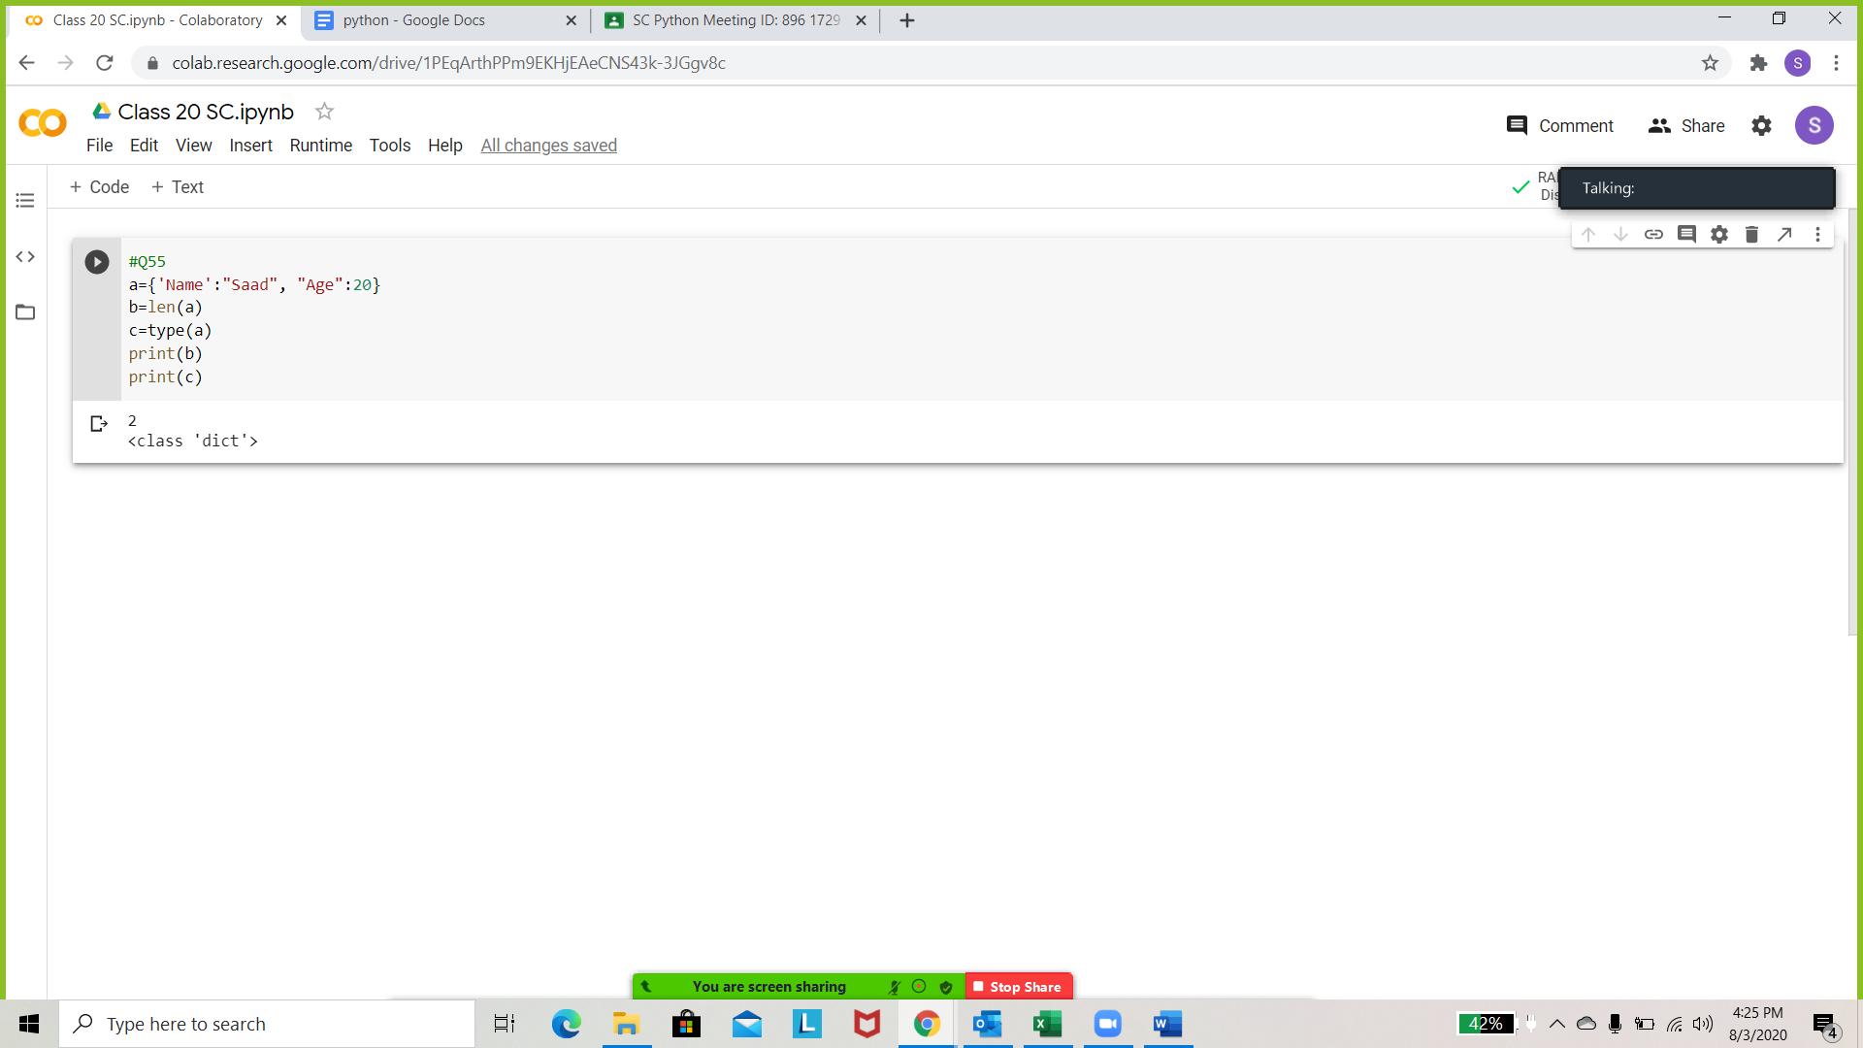

Write a Python program to add a key to a dictionary.

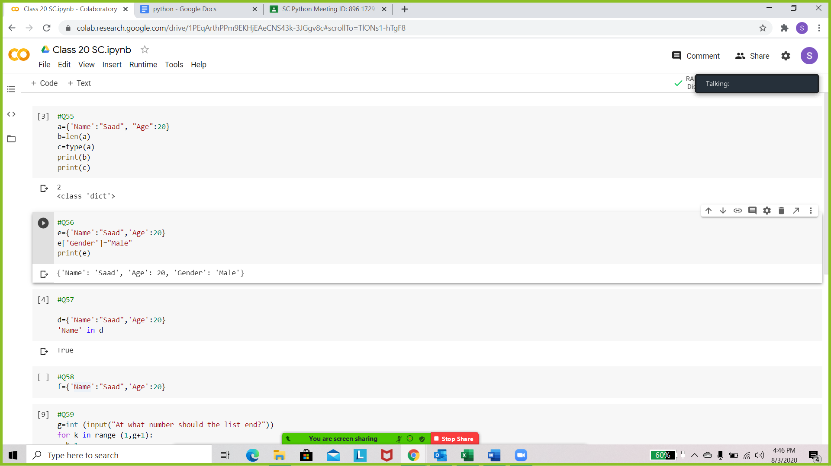

Write a Python script to check whether a given key already exists in a dictionary.

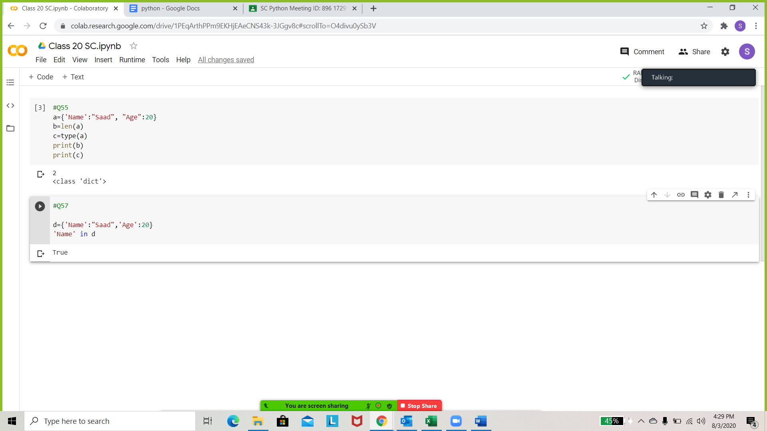

Write a Python program to iterate over dictionaries using for loops

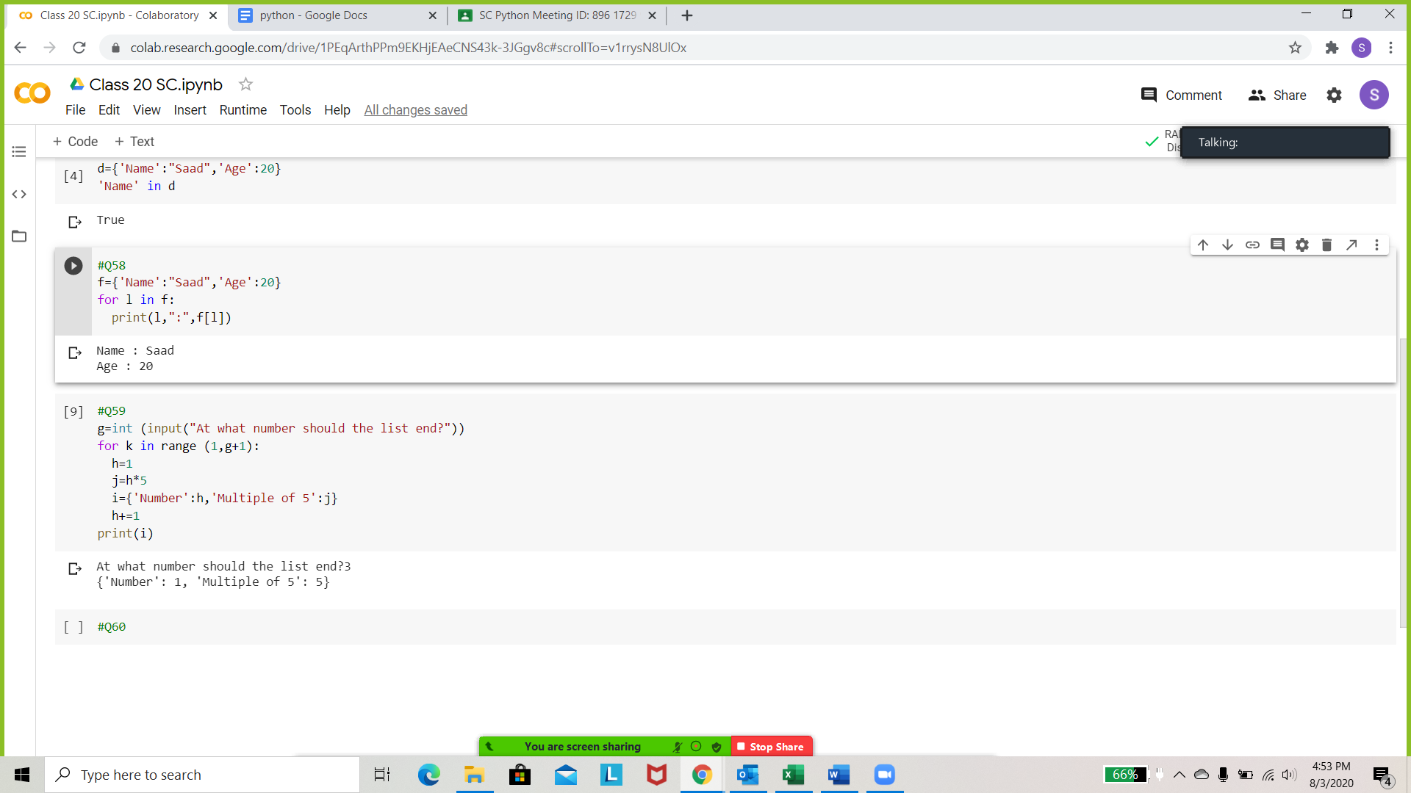

Write a Python script to generate and print a dictionary that contains a numbers between 1 and n (defined by the user) in the form (x, x\*\*5).

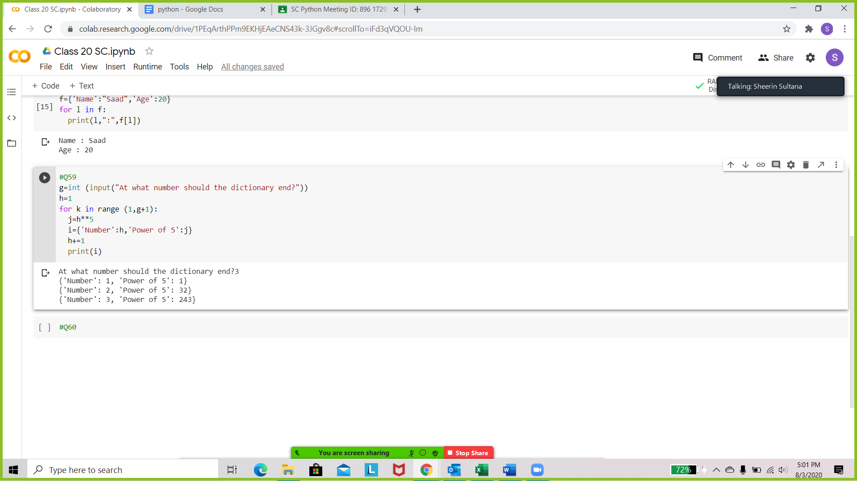

Write a Python program to sum all the values in a dictionary. (use sum() )

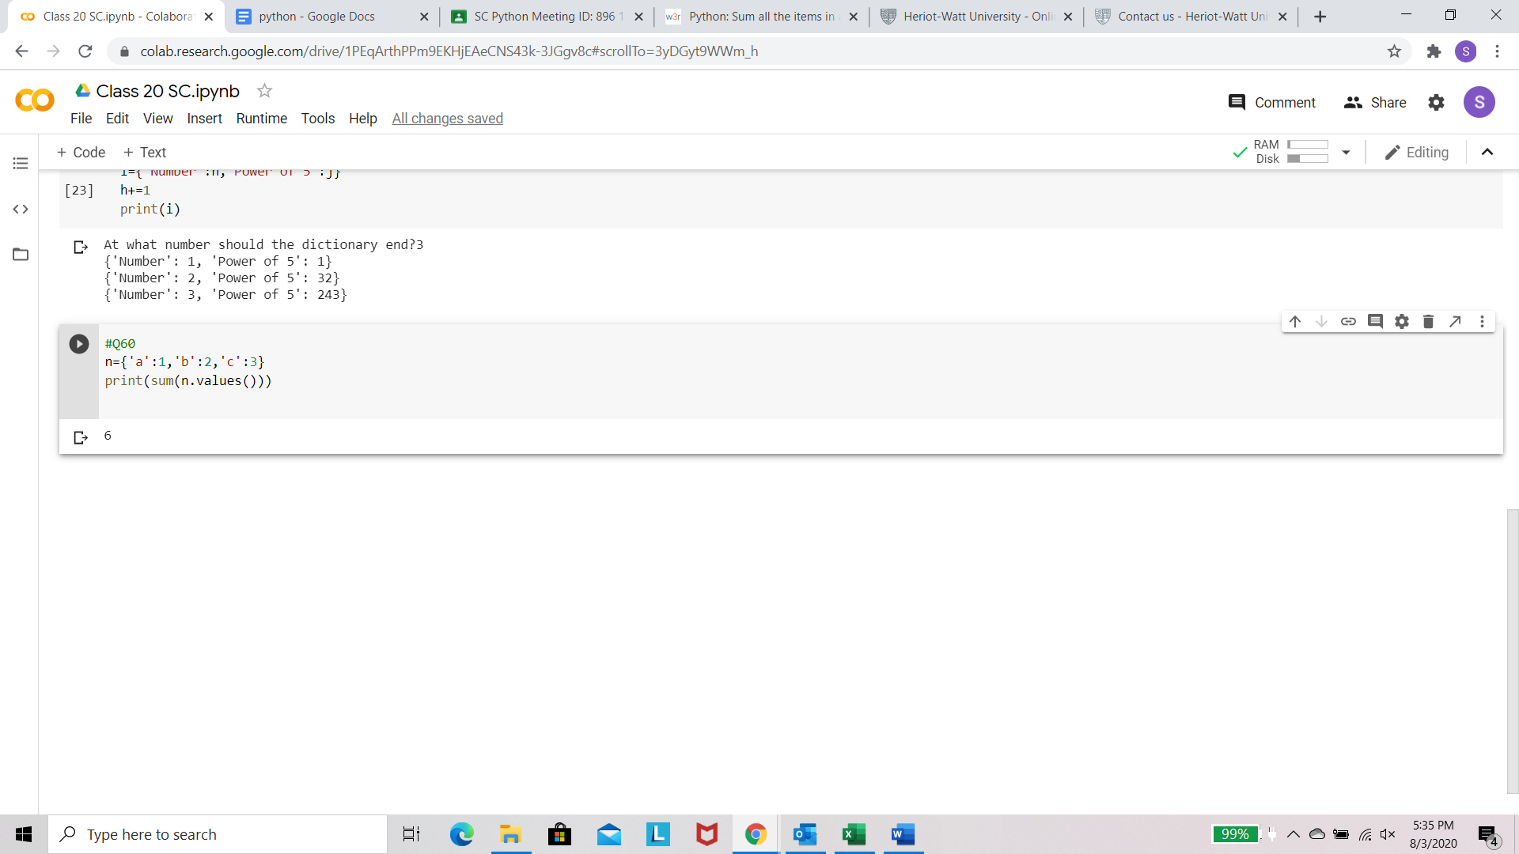

Write a Python program to combine two dictionaries adding values for common keys.

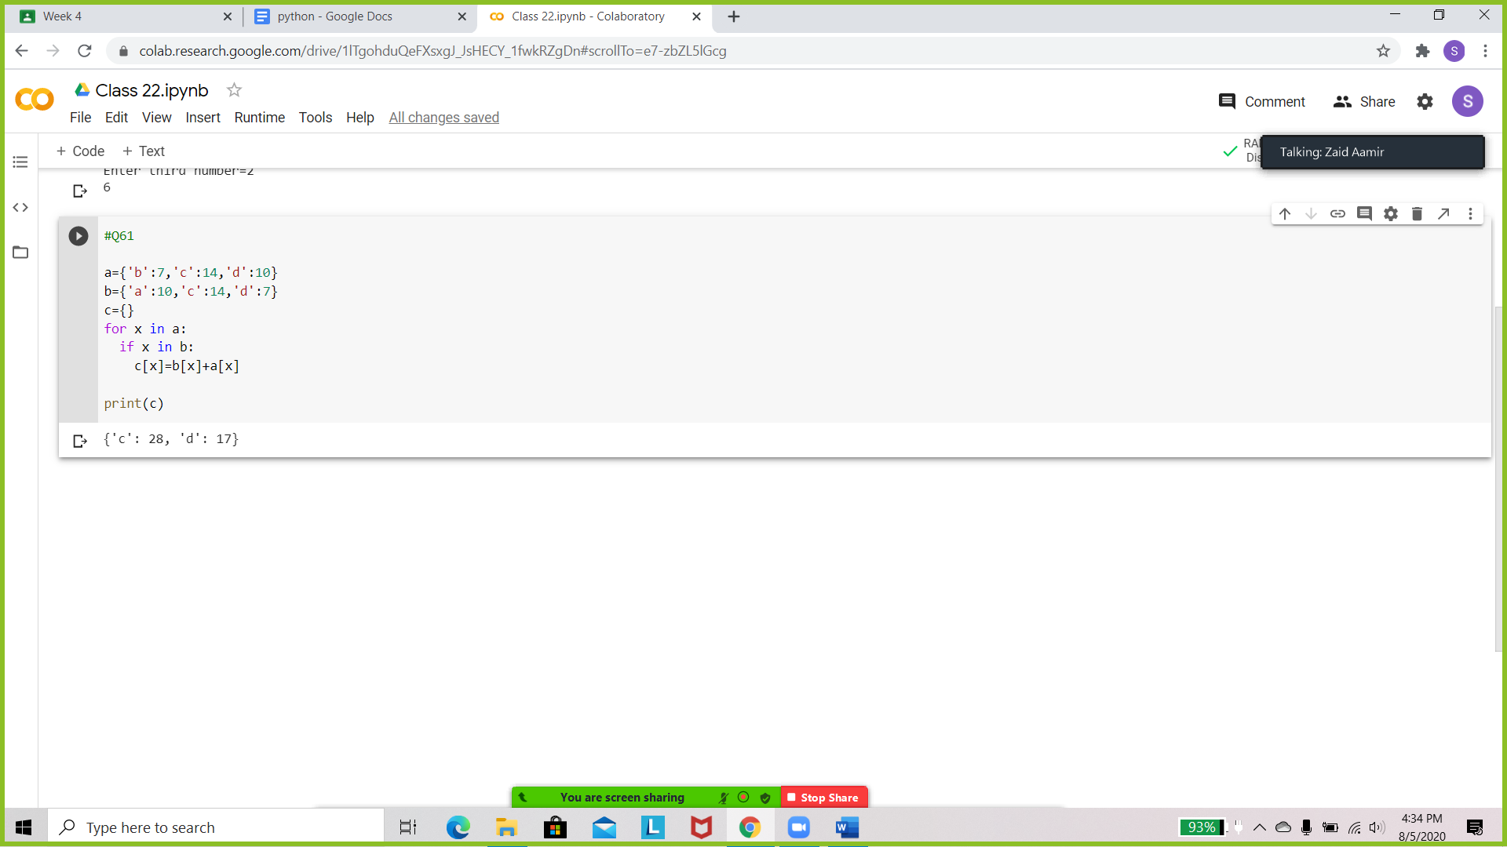

Write a Python program to print all unique values in a dictionary.

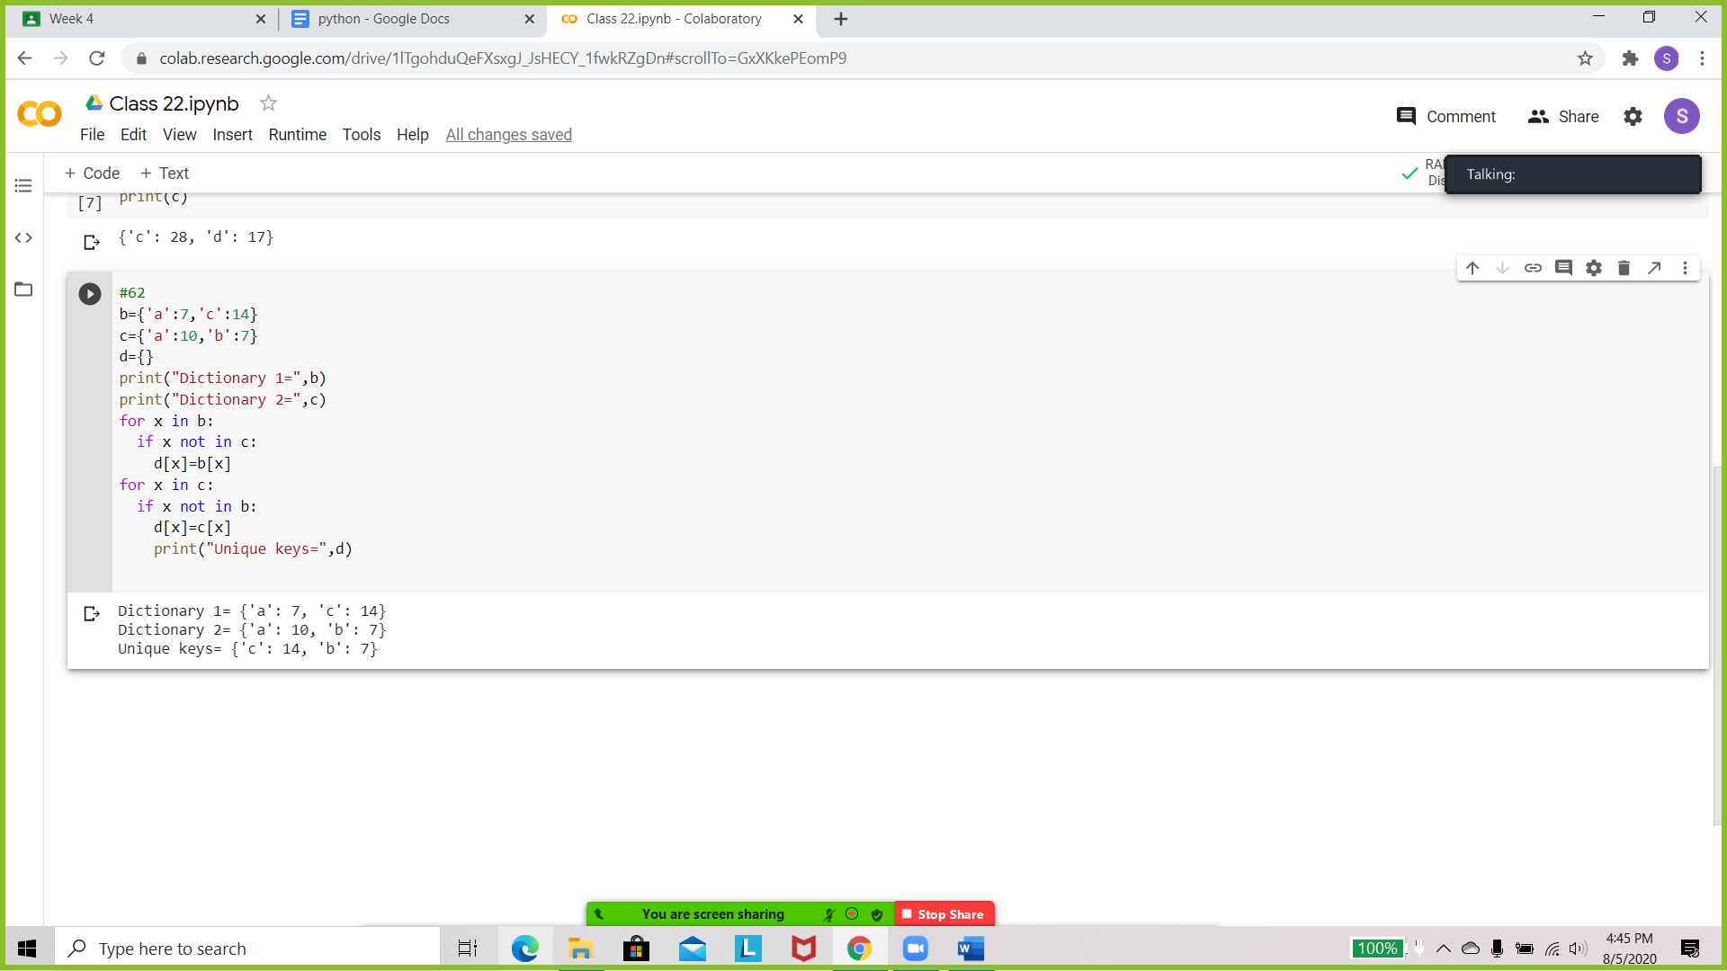

Write a Python program to create a dictionary of keys x, y, and z where each key has as value a list from 11-20, 21-30, and 31-40 respectively. Access the fifth value of each key from the dictionary.

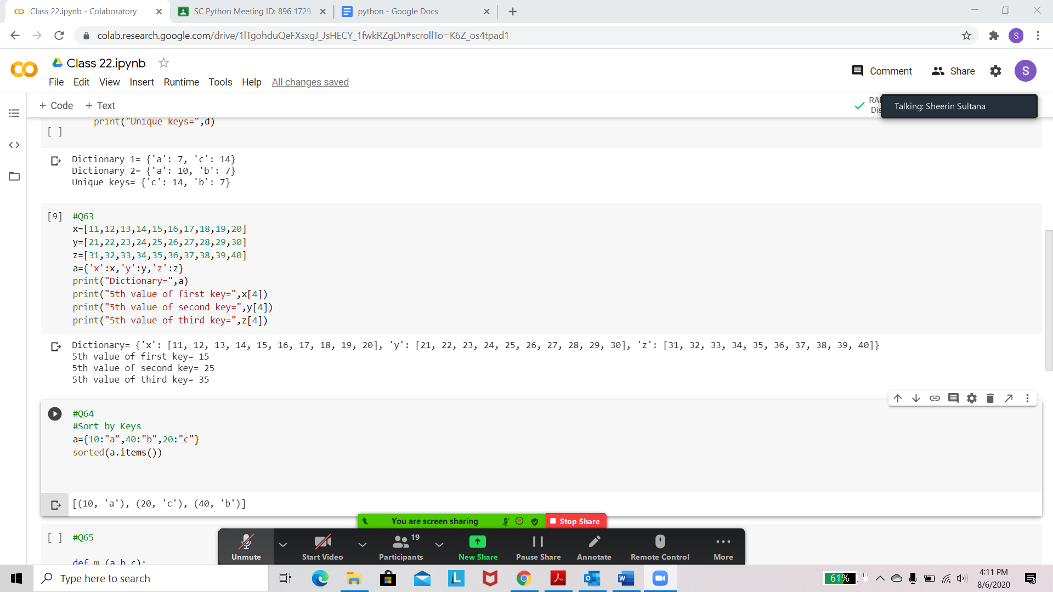

Write a program to sort dictionaries, values and keys.



Write a Python function to find the Max of three numbers.

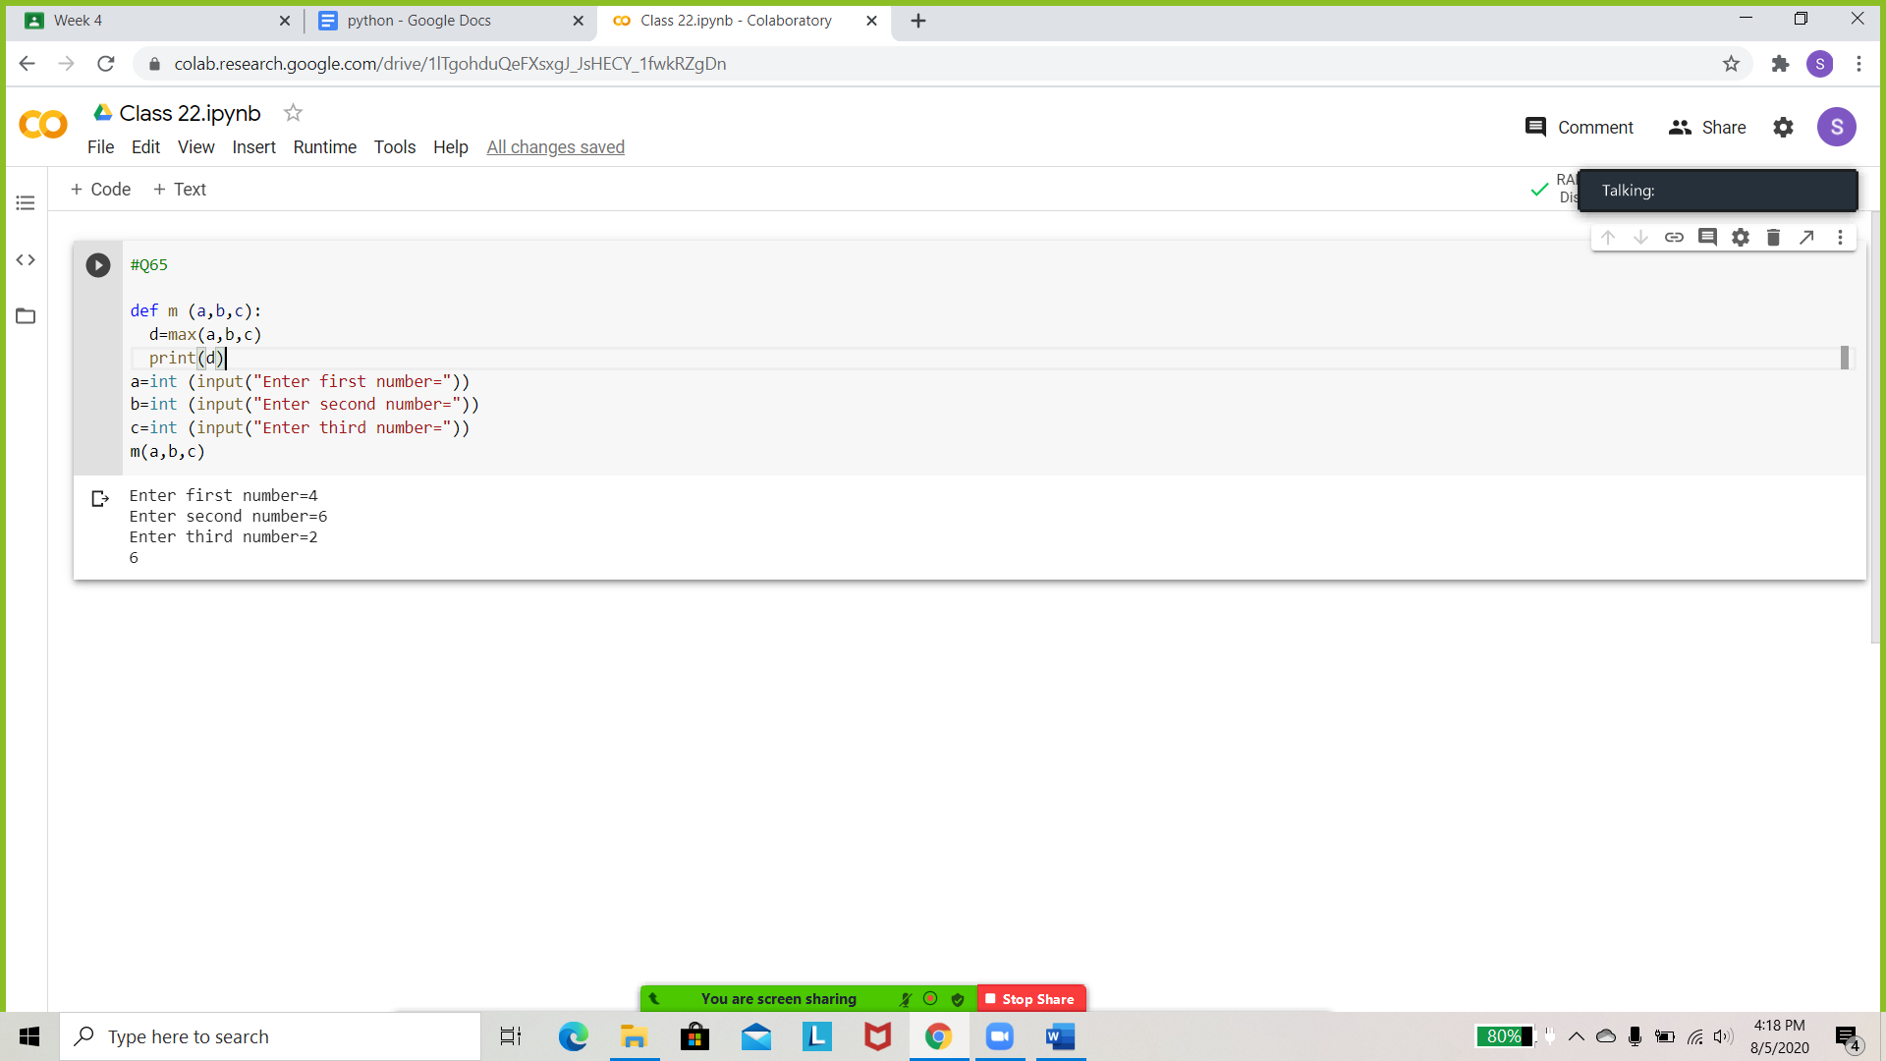

Write a Python function that takes a number as a parameter and checks if the number is prime or not.

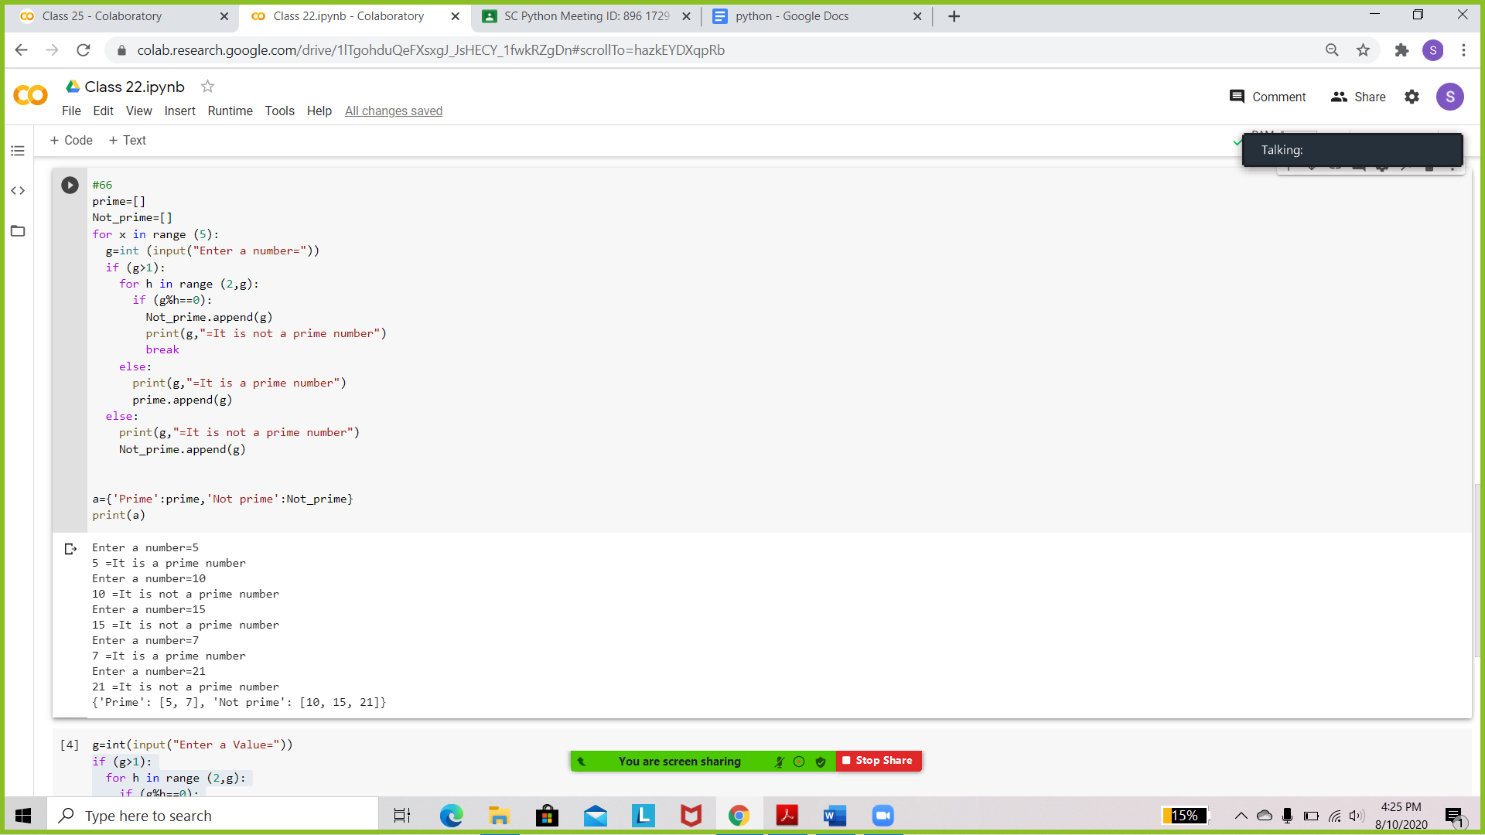

Write a Python function that accepts a hyphen-separated sequence of words as input and prints the words in a hyphen-separated sequence after sorting them alphabetically. Sample Items : green-red-yellow-black-white. Expected Result : black-green-red-white-yellow

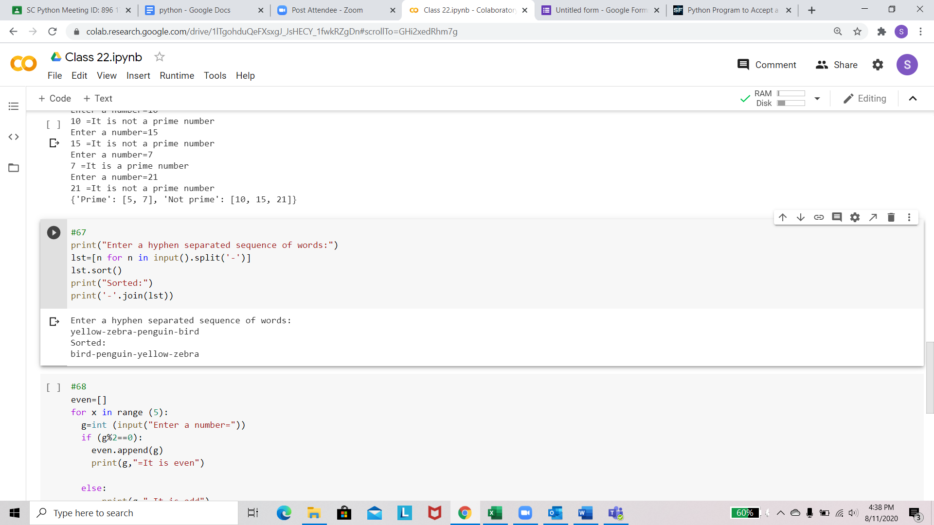

Write a Python function to print the even numbers from a given list.

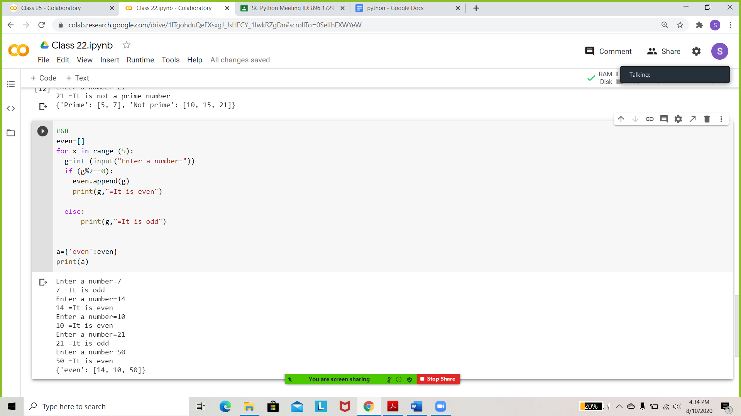

Write a Python function that accepts a string and calculates the number of uppercase letters and lowercase letters.

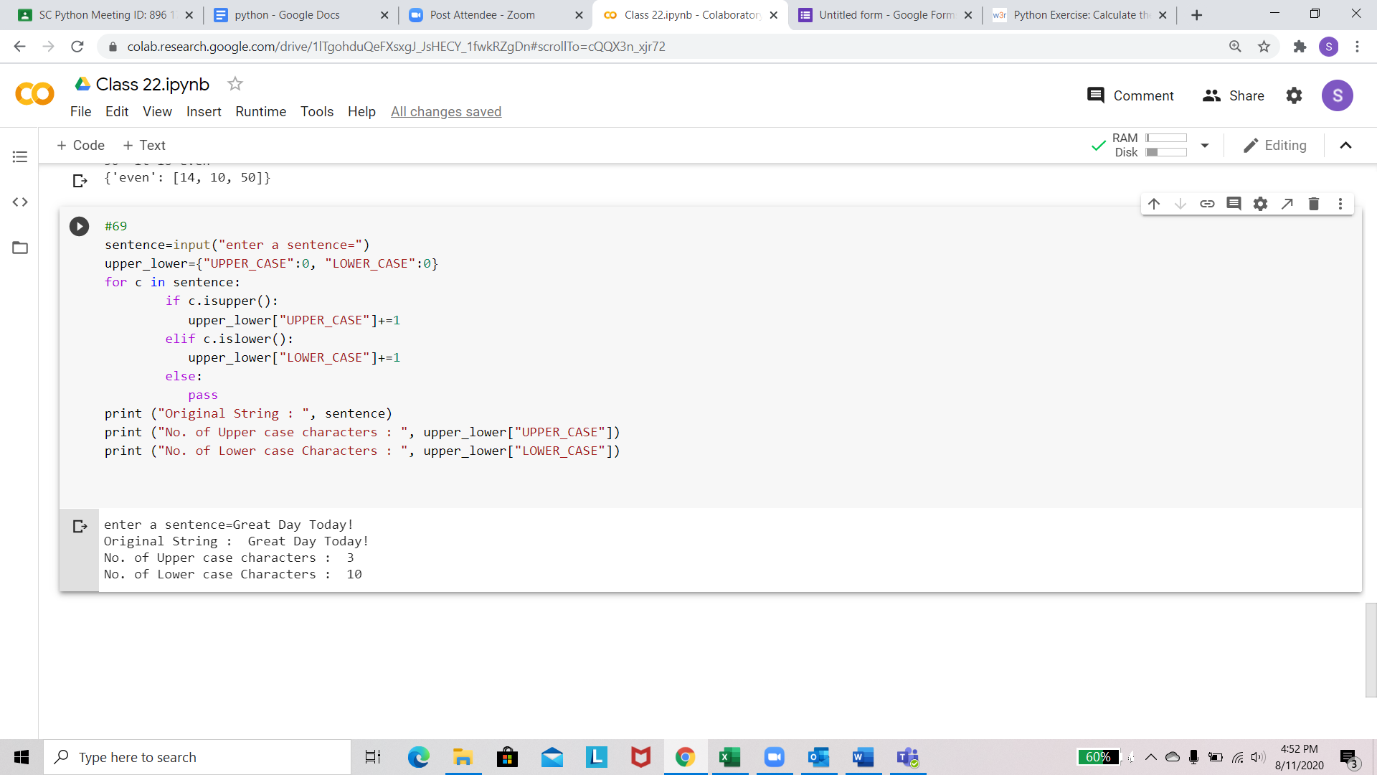

Write a function for Happy Numbers - A happy number is defined by the following process. Starting with any positive integer, the sum of the squares of its digits equals 1 else they are unhappy numbers.

